**REVERSIBLE DATA HIDING IN ENCRYPTED IMAGES BY RESERVING ROOM BEFORE ENCRYPTION**

## A project report submitted for the degree of Bachelor of Engineering in Information Technology

## by

**SONIA BHANDI (171051002)**

**AMRITDAS VAISHNAV (171051063)**

**KAMESH PHEGADE (171051030)**

## Under the guidance of

**Prof. S. P. JOSHI**

Department of Information Technology

A.C.Patil College Of Engineering, Kharghar,

Navi Mumbai. University of Mumbai.

2020-2021

Jawahar Education Society’s

A. C. Patil College of Engineering, Kharghar

**CERTIFICATE**

This is to certify that the project entitled

**REVERSIBLE DATA HIDING IN ENCRYPTED IMAGES BY RESERVING ROOM BEFORE ENCRYPTION**

By

SONIA BHANDI (171051002)

AMRITDAS VAISHNAV (171051063)

KAMESH PHEGADE (171051030)

is successfully completed for the degree of Bachelor of Engineering as prescribed by University of Mumbai.

Prof. S. P.Joshi

Guide HOD

Examiner1 Examiner2

Dr. V. N. Pawar

Principal

**Project Report Approval for B. E.**

This project report entitled **REVERSIBLE DATA HIDING IN ENCRYPTED IMAGES BY RESERVING ROOM BEFORE ENCRYPTION** by **SONIA BHANDI,KAMESH PHEGADE** AND **AMRITDAS VAISHNAV** is approved for the degree of Bachelor of Engineering in Information Technology.

Examiner1 Examiner 2

Name: Name:

Date: Date:

Place: Place:

**DECLARATION**

I declare that this written submission represents my ideas and does not involve plagiarism. I have adequately cited and referenced the original sources wherever other’s ideas or words have been included. I also declare that I have adhered to all principles of academic honesty and integrity and have not misrepresented or fabricated or falsified any idea/data/fact/source in my submission. I understand that any violation of the above will be cause for disciplinary action against me by the Institute and can also evoke penal action from the sources which have thus not been properly cited or from whom proper permission has not been taken when needed.

Date:

SONIA BHANDI GALWE (171051002)

KAMESH PHEGADE (171051030)

AMRITDAS VAISHNAV (171051063)

**Abstract**

Reversible data hiding (RDH) in images is a technique, by which the original cover can be lossless recovered after the embedded message is extracted. This important technique is widely used in medical imagery, military imagery and law forensics, where no distortion of the original cover is allowed. Recently, more and more attention is paid to reversible data hiding (RDH) in encrypted images, since it maintains the excellent property that the original cover can be lossless recovered after embedded data is extracted while protecting the image content’s confidentiality. All previous methods embed data by reversibly vacating room from the encrypted images, which may be subject to some errors on data extraction and/or image restoration.

I

Contents

|  |  |  |
| --- | --- | --- |
|  | Abstract | **I** |
|  | List of figures | **II** |
| **1** | **Introduction** | **1** |
| **1.1** | Introduction | **1** |
| **1.2** | Motivation | **2** |
| **1.3** | Problem Statement | **2** |
| **2** | **Literature Survey** | **3** |
| **2.1** | Literature Review | **3** |
| **2.2** | Objective | **5** |
| **2.3** | Scope | **6** |
| **3** | **Proposed Methodology** | **7** |
| **3.1** | Activity Diagram | **7** |
| **3.2** | Data Flow Diagram | **8** |
| **3.3** | Use Case Diagram | **10** |
| **3.4** | Description of Modules | **10** |
| **4** | **Implementation Methodology** | **12** |
| **4.1** | Algorithms | **12** |
| **4.1.1** | OpenCv Algorithm | **12** |
| **4.1.2** | FisherFaces Algorithm | **13** |
| **4.1.3** | Linear Search Algorithm | **14** |
| **5** | **Results** | **15** |
| **5.1** | Home Page | **15** |
| **5.2** | Admin Login and Registration | **16** |
| **5.3** | Admin Privilege | **17** |
| **5.4** | User Login and Registration | **17** |
| **5.5** | After Login Home Page | **18** |
| **5.6** | Song Search | **18** |
| **5.7** | Emotion Mode | **19** |
| **5.7.1** | Happy Mood | **19** |
| **5.7.2** | Sad Mood | **19** |
| **5.7.3** | Neutral Mood | **20** |
| **5.7.4** | Angry Mood | **20** |
| **5.7.5** | Input for the Moods | **21** |
| **5.8** | Queue Mode | **21** |
| **5.9** | Empty Queue | **22** |
| **6** | **Plan of Work** | **23** |
| **7** | **Future Scope** | **24** |
| **8** | **Conclusion** | **25** |
| **9** | **References** | **26** |

List of Figures

|  |  |  |
| --- | --- | --- |
| **3.1** | Activity Diagram | **7** |
| **3.2** | DFD Level 0 | **8** |
| **3.3** | DFD Level 1 | **8** |
| **3.4** | DFD Level 2 | **9** |
| **3.5** | Use Case Diagram | **10** |
| **5.1** | Home Page | **15** |
| **5.1.1** | Home Page | **15** |
| **5.2** | Admin Registration | **16** |
| **5.3** | Admin Login | **16** |
| **5.4** | Admin Privilege | **17** |
| **5.5** | User Registration | **17** |
| **5.6** | After Login Home Page | **18** |
| **5.7** | Song Search | **18** |
| **5.8** | Happy Mood | **19** |
| **5.9** | Sad Mood | **19** |
| **5.10** | Neutral Mood | **20** |
| **5.11** | Angry Mood | **20** |
| **5.12** | Inputs for the Mood | **21** |
| **5.13** | Queue Mode | **21** |
| **5.13.1** | Queue Mode | **22** |
| **5.14** | Empty Queue | **22** |
| **6.1** | Gantt Chart | **23** |

II

**CHAPTER 1**

**Introduction**

In this chapter, we briefly described our research work and gave a complete overview of our work including the problem statement. Later, other parts of this report contain more information about our work and implementation.

* 1. **EXISTING SYSTEM**

1. M.Murali Krishna, Nirmal Roberts proposed Steganography is a technique used to hide a message inside an image. Reversible steganography aims at recovering cover image without distortions while extracting secret messages at the receiver side. The two main existing problems in this steganography are, how to obtain high embedding capacity without compromising on the cover image quality, and confidentiality of embedded messages. In this paper, we present a new technique of reversible steganography using the IMNP algorithm with DES preprocessing of embedded messages. IMNP algorithm allows to maintain good image quality and increases embedding capacity. DES preprocessing provides an extra layer of security to message. The experimental results show that the proposed technique outperforms existing techniques of Steganography in terms of embedding capacity and image quality. It further provides good security to messages.
2. S. Ariavazhang,c. Karthika introduced In this project,space for embedding data is reserved with pairwise prediction error expansion(PEE) and histogram shift before encryption has been performed, so that data hider can reversibly embed data into an encrypted image easily. Image redundancy is better exploited in prediction error expansion which leads to superior performance. But in the current PEE based method, correlation within prediction error is not better exploited. Hence to better exploit the correlation among prediction errors, two prediction errors are jointly considered. Then the embedding is based on the prediction error pair and its 2D prediction-error histogram, which leads to improved performance. Secret data extraction and image restoration in this method.By this method, higher PSNR is achieved than any other method in reversible data hiding.
3. XiaoLong Li and Yun-Qing shi, In this paper, the various RDH algorithms and researches have been classified into the following six categories: 1) RDH into image spatial domain; 2) RDH into image compressed domain (e.g., JPEG); 3) RDH suitable for image semi-fragile authentication; 4) RDH with image contrast enhancement; 5) RDH into encrypted images, which is expected to have wide application in the cloud computation; and 6) RDH into video and into audio. For each of these six categories, the history of technical developments, the current state of the arts, and the possible future research are presented and discussed. It is expected that the RDH technology and its applications in the real word will continue to move ahead.
4. Pauline Puteaux,William puech introduced the theory of An original image is encrypted with a secret key and during or after its transmission, it is possible to embed additional information in the encrypted image, without knowing the encryption key or the original content of the image. During the decoding process, the secret message can be extracted and the original image can be reconstructed. In the last few years, RDHEI has started to draw research interest. Indeed, with the development of cloud computing, data privacy has become a real issue. However, none of the existing methods allow us to hide a large amount of information in a reversible manner. In this paper, we propose a new reversible method based on MSB (most significant bit) prediction with a very high capacity. We present two approaches, these are: high capacity reversible data hiding approach with correction of prediction errors and high capacity reversible data hiding approach with embedded prediction errors. With this method, regardless of the approach used, our results are better than those obtained with current state of the art methods, both in terms of reconstructed image quality and embedding capacity.

## **PROBLEM DEFINITION**

To develop a GUI based Desktop application for encryption and decryption in an image,with the cryptography and steganography techniques and using RSA algorithm without changing or disturbing the quality of the picture or image.

* 1. **LITERATURE REVIEW**

|  |  |  |  |  |
| --- | --- | --- | --- | --- |
| **SR NO.** | **AUTHOR’S NAME** | **YEAR OF PUBLISHING** | **WORKING** | **DISADVANTAGE** |
| 1. | Lixin Luo, Zhenyong Chen, Ming Chen, Xiao Zeng, and Zhang Xiong | 2010 | Reversible image watermarking by interpolation Processing | Any mistake in the calculation of interpolation will affect the secret information. |
| 2. | X,Zhang | 2012 | Separable reversible data hiding in encrypted | Data compression is not efficient |
| 3. | W. Zhang, B. Chen | 2012 | Reversible data hiding schemes via optimal codes for binary covers | problem is whether there exists other more effective modifying methods or not |
| 4. |  |  |  |  |
| 5. |  |  |  |  |

**CHAPTER 2**

**Proposed System**

**2.1 Activity Diagram**

**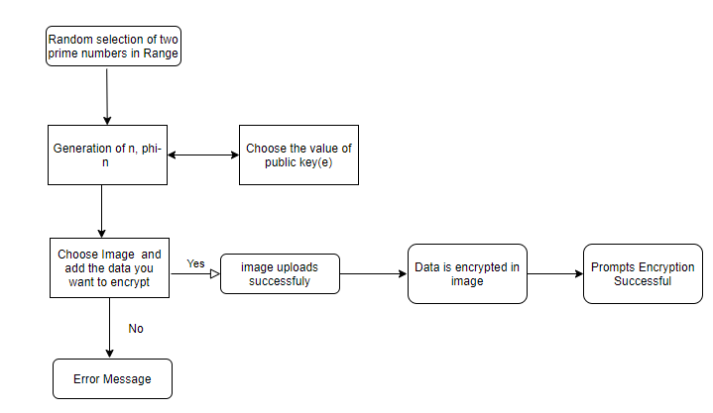**

**Fig. 2.1 Activity Diagram**

**2.2 Use Case Diagram**

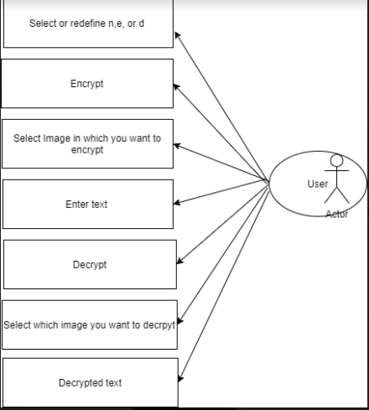

**Fig. 2.2 Use Case Diagram**

**2.4 Description of Module**

**In our proposed system , we are going to use the below stated modules.**

**Modules**

**1. Encrypted image generation-**In this module , to construct the encrypted image , the first stage can be divided into two steps:

**a. Image partition –** The goal of image partition here is to reserve room before encryption by using standard RDH technique.

**b. Self reversible embedding-** The goal of self reversible embedding is to embed the LSB-plains of image by employing traditional RDH algorithm.

1. **Data hiding in Image-**

Once the data hider acquires the encrypted image , we can embed some data into it , although we cannot get the access to the original image.

1. **Data extraction and image recovery-**

In this method if the recipient only has the encryption key, then the original image will be perfectly recovered .If the recipient only has the data–hiding key, then the secret data will be recovered . If the recipient has both the keys then the image and the secret data both can be available.

**CHAPTER 3**

**Implementation Methods**

**3.1 Algorithms**

**3.1.1 OPENCV ALGORITHM**

OpenCV uses machine learning algorithms to detect and recognize face, identify objects, classify human actions in videos, from camera to find similar images from an image database. OpenCV uses Haar Cascade classifier.

Haar cascade classifier is basically a machine learning based approach where a cascade function is trained from a lot of images both positive and negative. Based on the training it is then used to detect the objects in the other images.

OpenCV uses machine learning algorithms to search for faces within a picture. Because faces are so complicated, there isn’t one simple test that will tell you if it found a face or not. Instead, there are thousands of small patterns and features that must be matched. The algorithms break the task of identifying the face into thousands of smaller, bite-sized tasks, each of which is easy to solve. These tasks are also called classifier

OpenCV uses Cascade. Cascade is “a waterfall or series of waterfalls.”

Like a series of waterfalls, the OpenCV cascade breaks the problem of detecting faces into multiple stages. For each block, it does a very rough and quick test. If that passes, it does a slightly more detailed test, and so on. The algorithm may have 30 to 50 of these stages or cascades, and it will only detect a face if all stages pass

**STEPS FOR OPENCV ALGORITHM:**

1. Detect face using Haar cascade classifier.
2. Load the image and convert it into gray-scale.
3. After converting the image from RGB to Gray, the system will try to locate the exact features in face using “ detectMultiScale ” function.
4. From the above step, the function detectMultiScale returns 4 values – X-coordinate, Y-coordinate, width(w) and height(h) of the detected features of the face. Based on these 4 values system will draw a rectangle around the face.

**3.1.2 FISHER FACES ALGORITHM :**

Fisherfaces algorithm **extracts principle components that separates one individual from another**. So, now an individual's features can't dominate another person's features.

Image recognition using this algorithm is based on reduction of face space domentions using PCA method and then applying LDA method also known as Fisher Linear Discriminant (FDL) method to obtain characteristic features of image.

LDA is used to find a linear combination of features that separates two or more classes or objects. It can be used for dimension reduction before further classification. It attempts to model the difference between classes of data.

**STEPS FOR FISHERFACES ALGORITHM:**

1. Retreive data

Collection of data is done in form of face images. Collection can be done using photographs already saved or from a webcam. Face must be fully visible and must be facing forward.

1. Image Processing

a) Preprocessing stage: Getting images using camera or saved images and conversion from RGB to grayscale. Image data is divided into training and test data.

b) Processing stage: Fisherface method will be applied to generate feature vector of facial image data used by system and then to match vector of traits of training image with vector characteristic of test image using euclidean distance formula.

1. Feature generation

Features of the faces are extracted.

**3.1.3 LINEAR SEARCH ALGORITHM:**

In this algorithm, the search of a song name is done, and the related songs are to be displayed.

Linear search is a very basic and simple search algorithm. In Linear search, we search an element or value in each array by traversing the array from the starting, till the desired element or value is found.

**STEP FOR LINEAR SEARCH**

1. Traverse the array using a for loop.
2. In every iteration, compare the target value with the current value of the array.
3. If the values match, return the current index of the array.
4. If the values do not match, move on to the next array element.
5. If no match is found, return -1.

**CHAPTER 4**

**Development Tools**

**HARDWARE REQUIREMENT**

1. The recommended system can work on any internet connected device. These devices should have some limit requirements to make the application run effectively. We expect that the processor speed and internet speed are high.
2. Other Requirements can be:
3. Processor: 2Ghz
4. RAM: 1 GB

**SOFTWARE REQUIREMENT:**

1. Python, JavaScript, MySql
2. Machine learning
3. Data science

**CHAPTER 5**

**Result and Discussion**

**Results**

**5.1 Home Page**



**Fig. 5.1 Home Page**

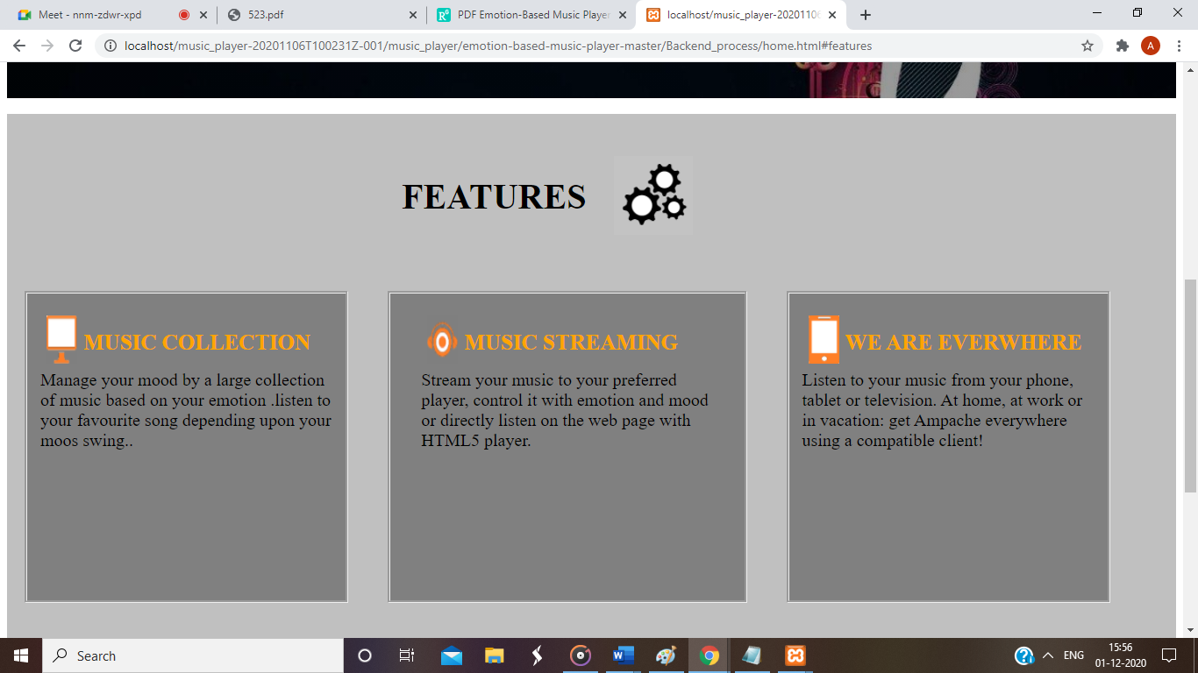

**Fig. 5.1.1 Home Page**

**5.2 Admin Login and Registration**

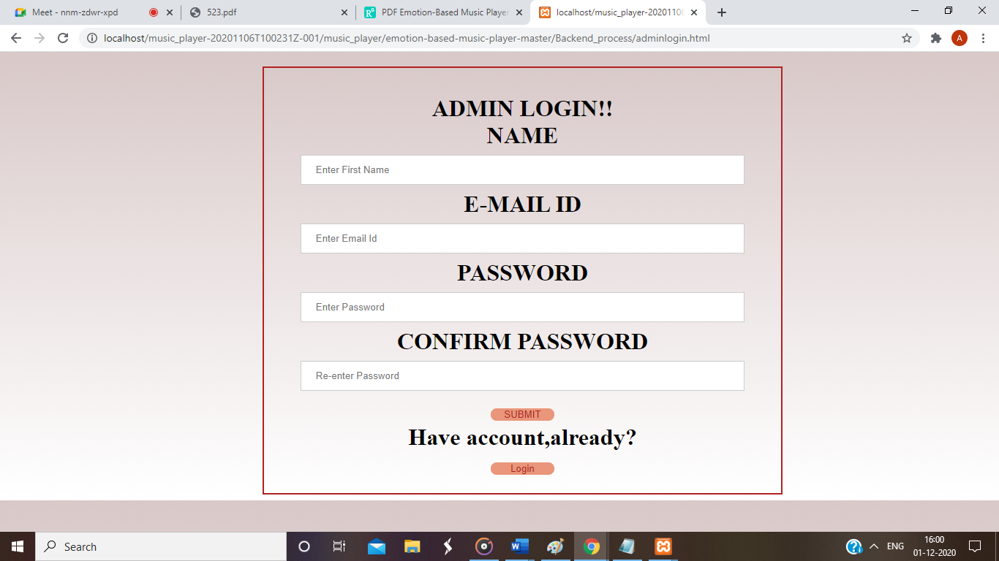

**Fig. 5.2 Admin Registration**

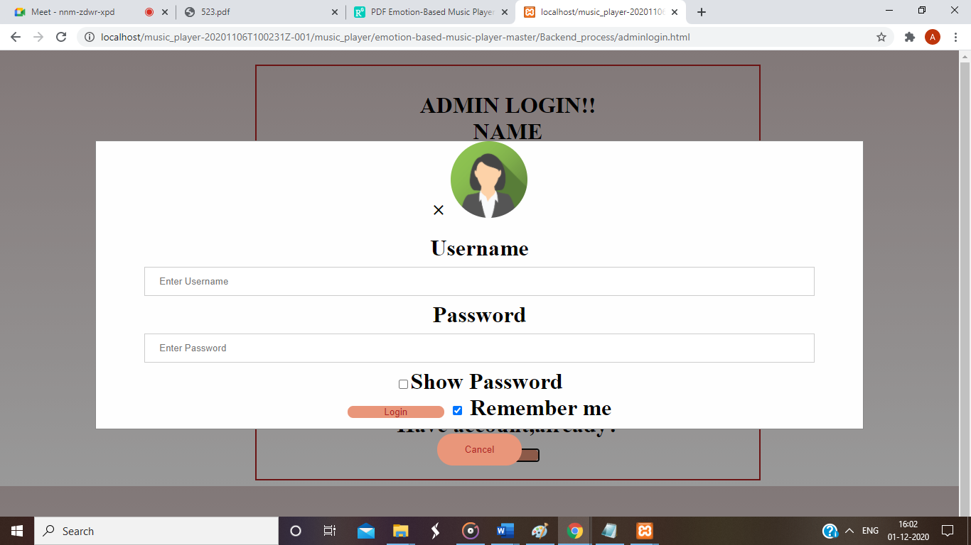

**Fig. 5.3 Admin Login**

**5.3 Admin Privilege**



**Fig. 5.4 Admin Privilege**

**5.4 User Login and Registration**

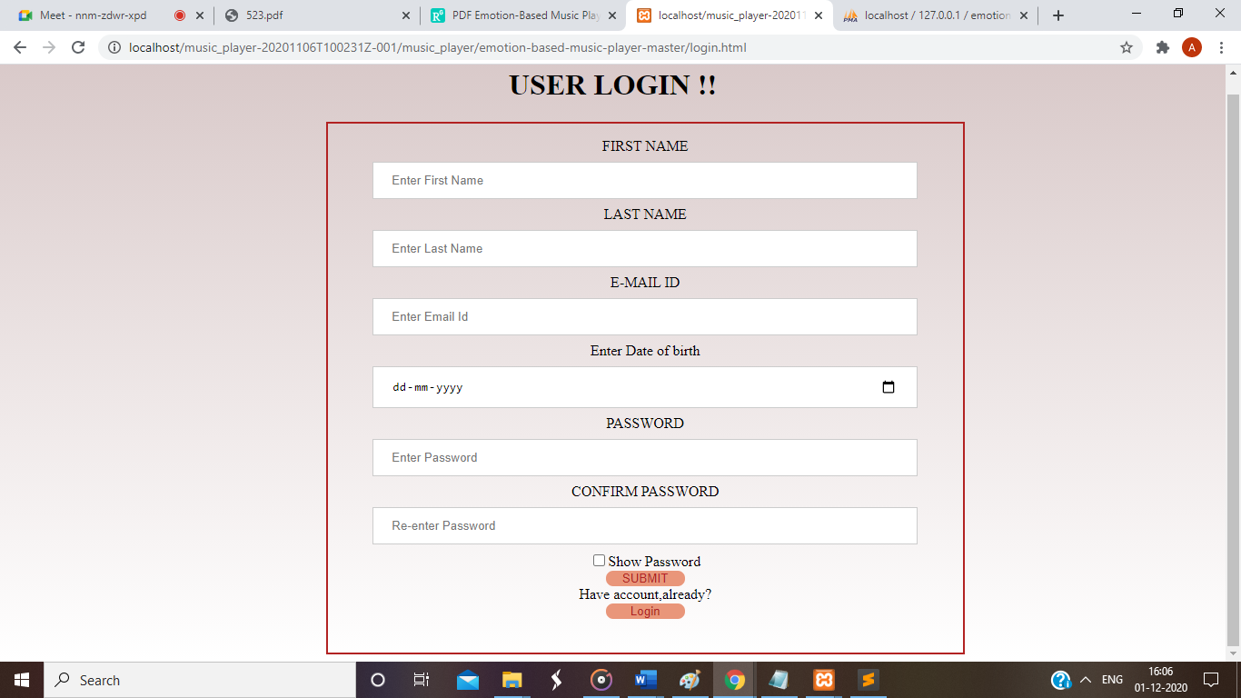

**Fig. 5.5 User Registration**

* 1. **After Login Home Page**



**Fig.** **5.6 After Login Home Page**

* 1. **Song Search**

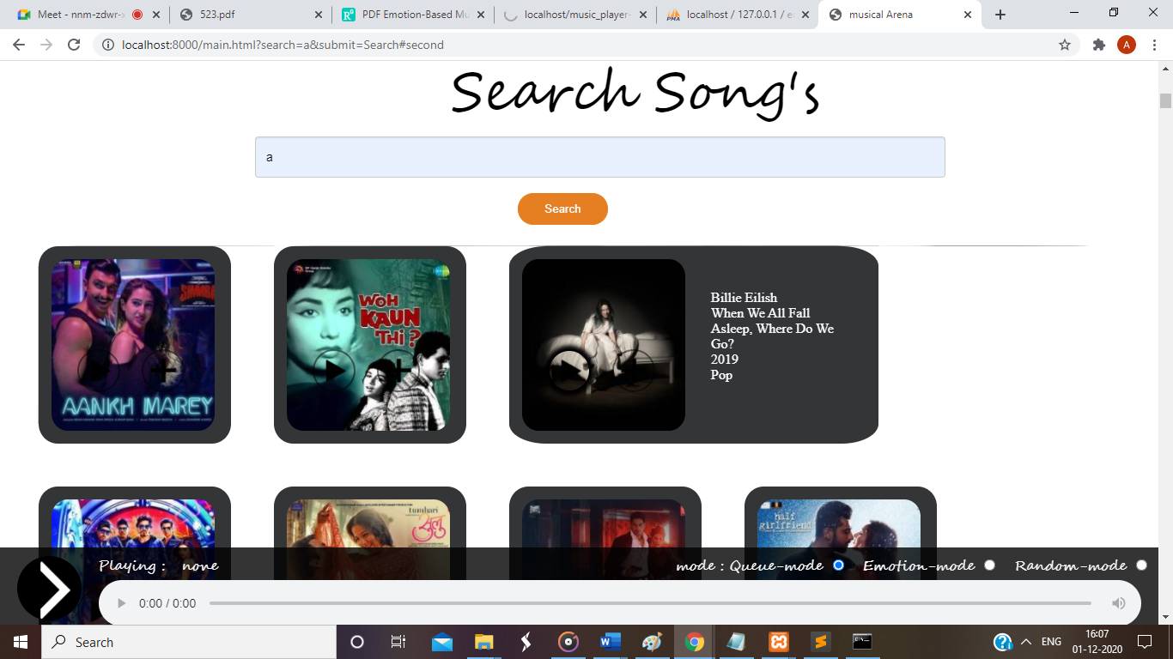

**Fig. 5.7 Song Search**

* 1. **Emotion Mode**

**5.7.1 Happy mood**

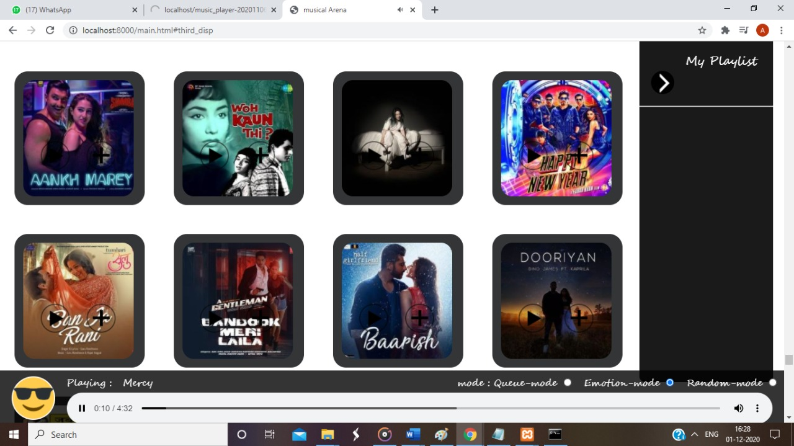

**Fig. 5.8 Happy Mood**

**5.7.2 Sad Mood**

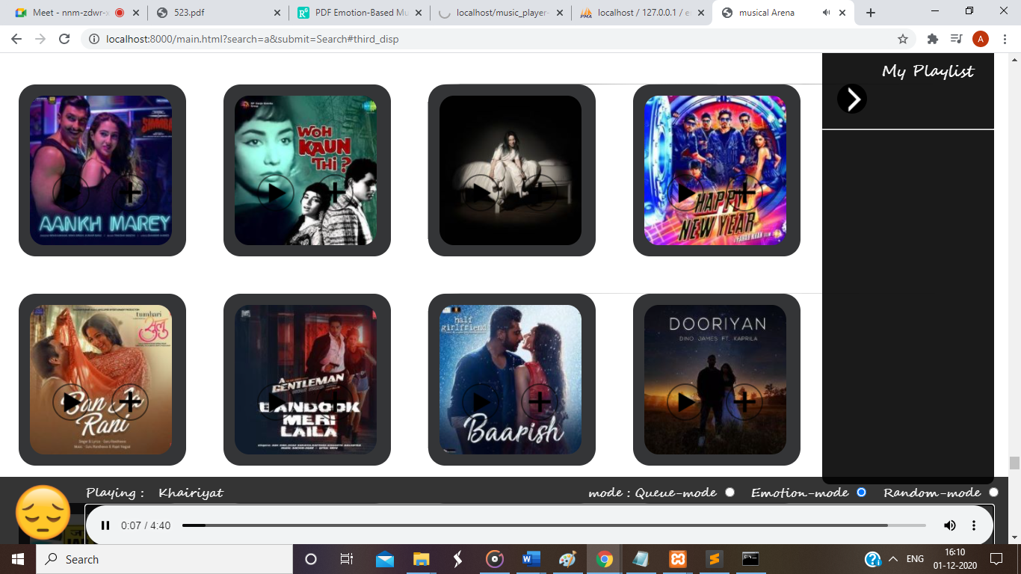

**Fig. 5.9 Sad Mood**

**5.7.3 Neutral Mood**

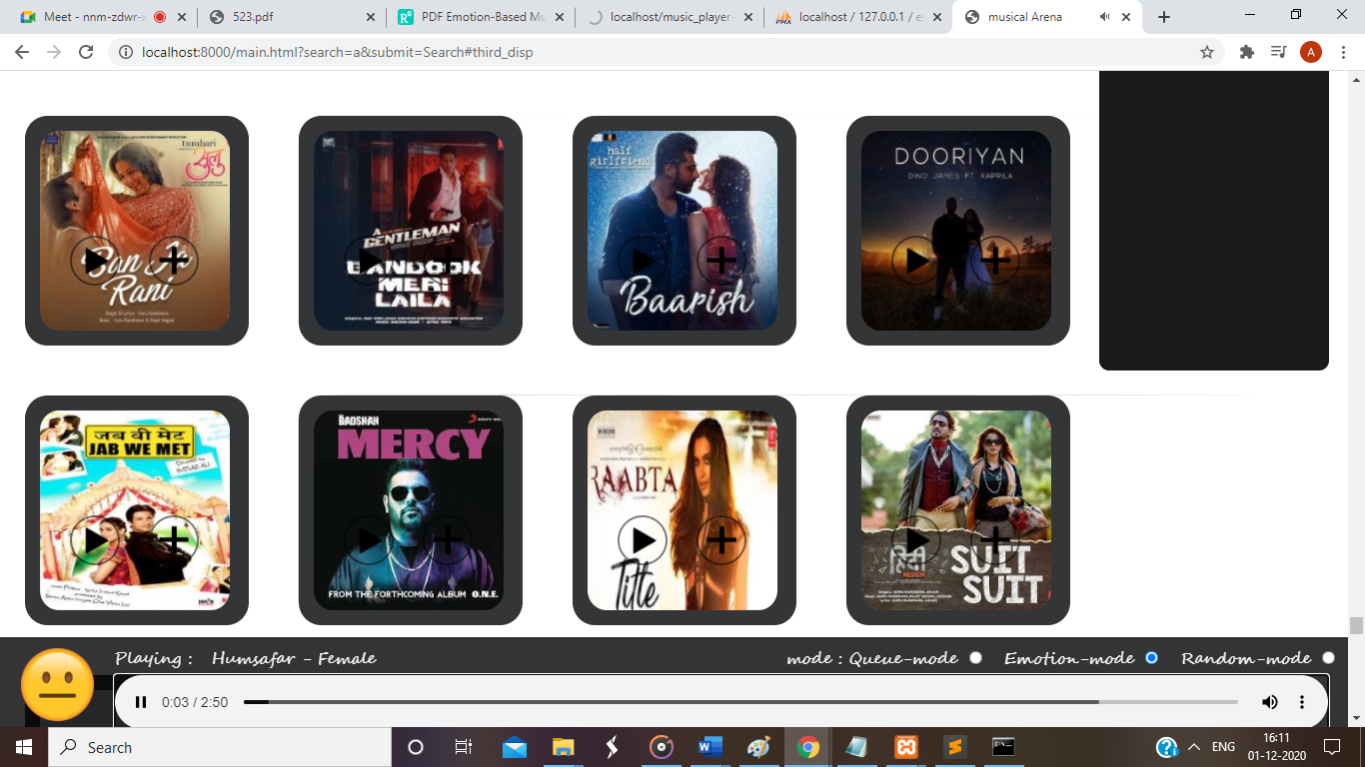

**Fig. 5.10 Neutral Mood**

**5.7.4 Angry Mood**

**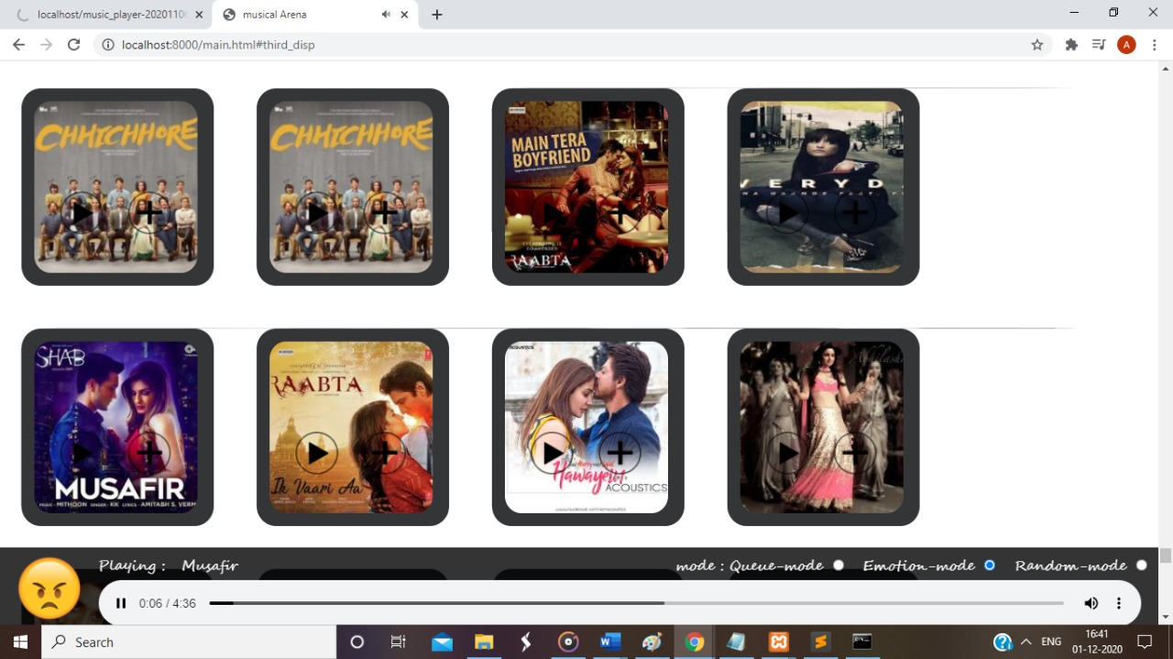**

**Fig. 5.11 Angry Mood**

* + 1. **Input for the moods**

**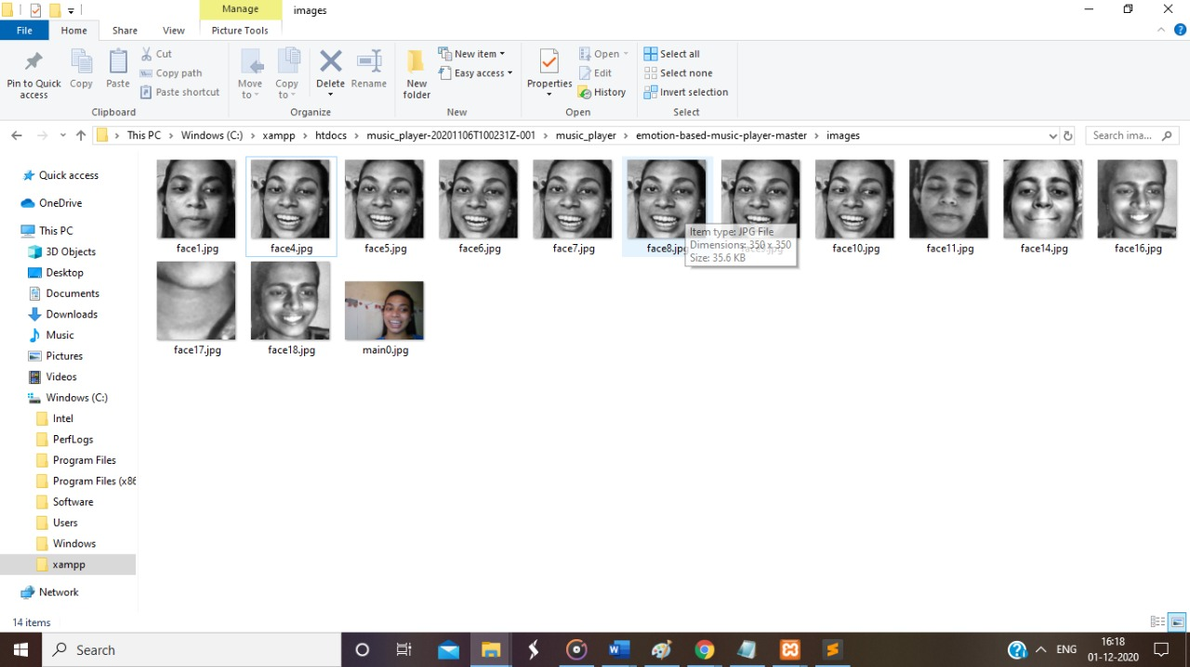**

**Fig. 5.12 Inputs for the moods**

* 1. **Queue Mode**

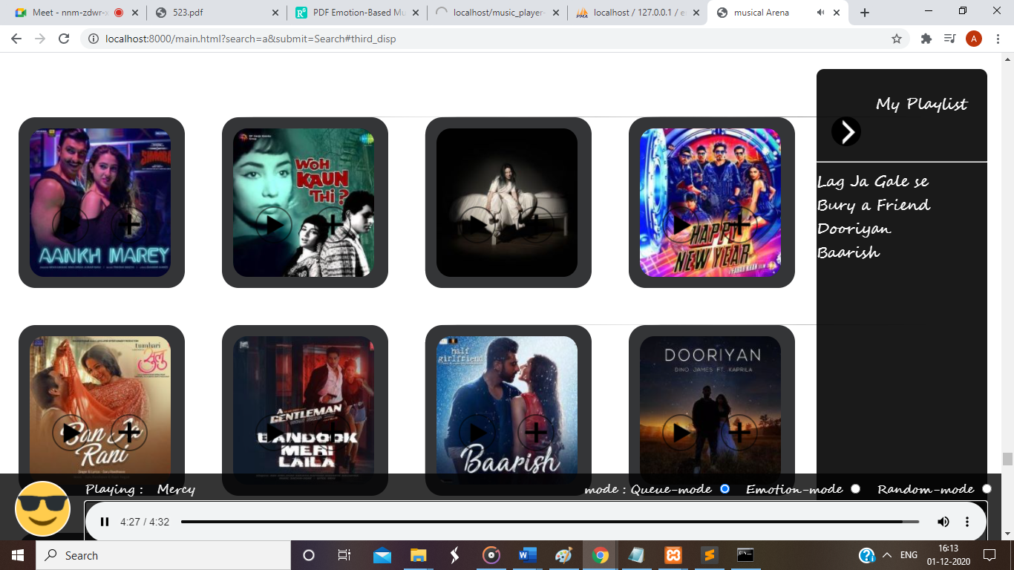

**Fig. 5.13 Queue Mode**

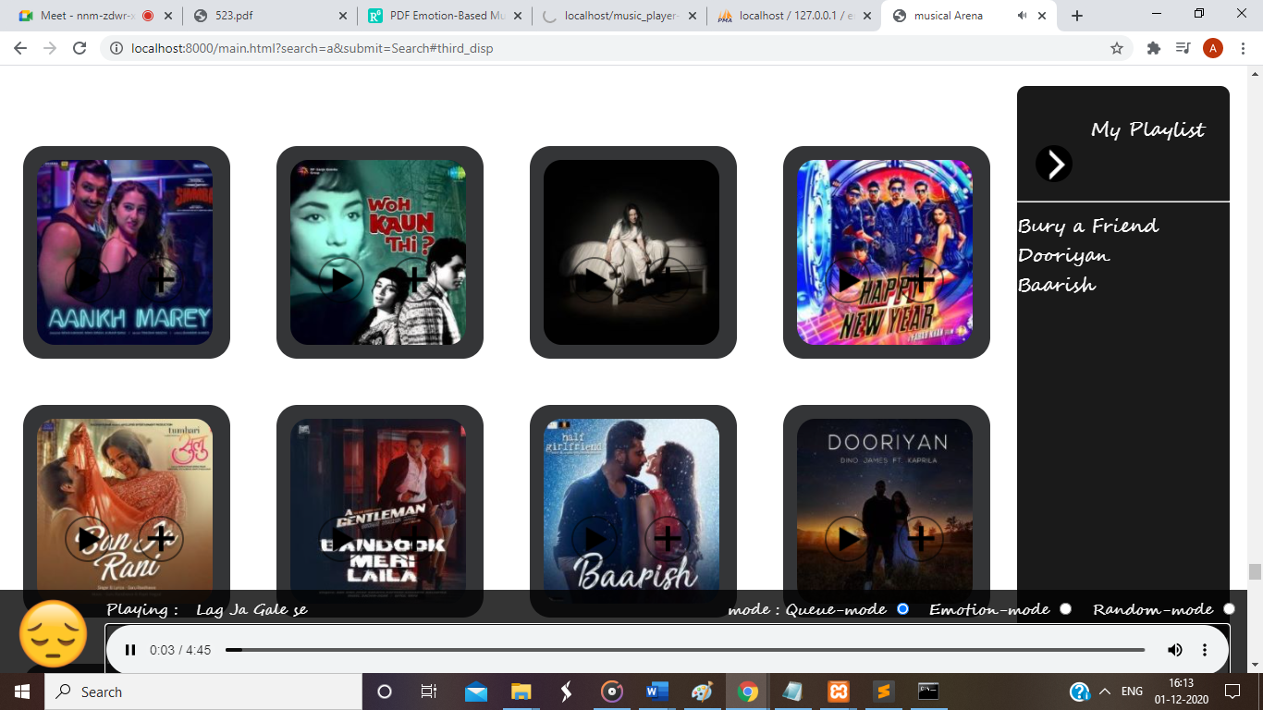

**5.13.1 Queue Mode**

* 1. **Empty Queue**

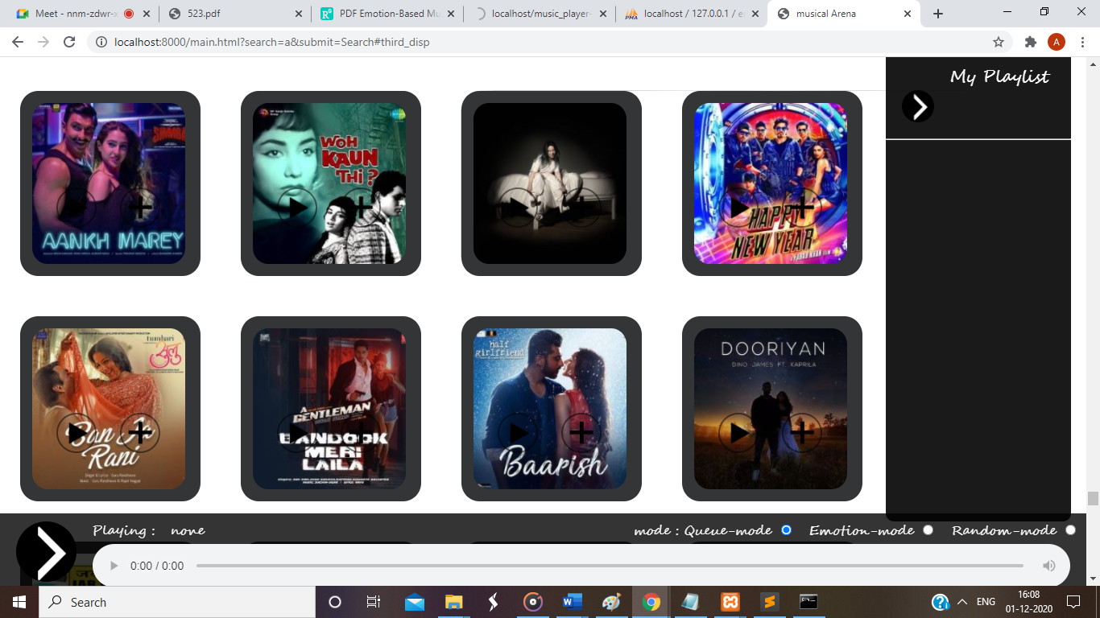

**5.14 Empty Queue**

**CHAPTER 6**

**Plan of Work**

**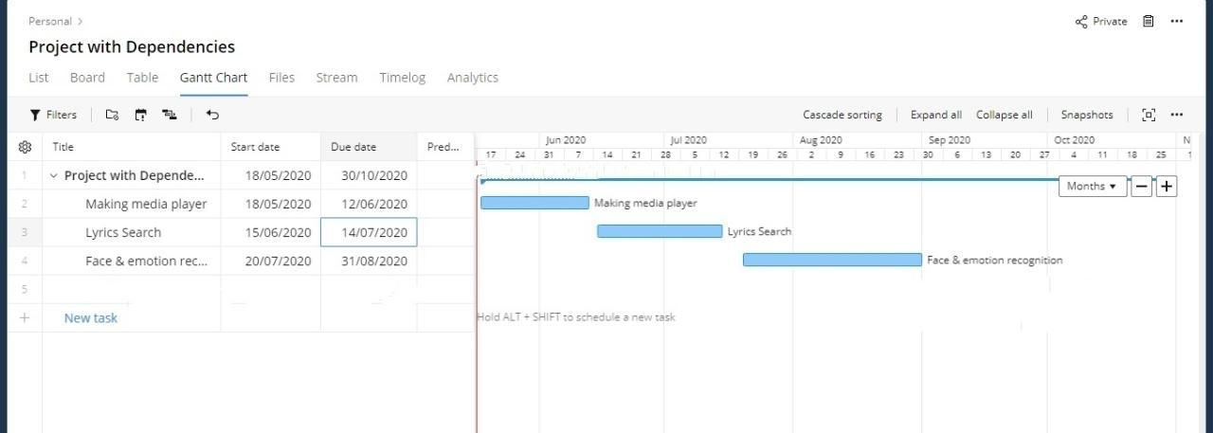**

**Fig. 6.1 Gantt Chart**

**CHAPTER 7**

**Conclusion**

Music Player has changed in many ways since it was first introduced. Now-a-days people like to get more out of different applications, so the designing of applications and the thought process behind it has changed. The users prefer more interactive & sophisticated yet simple to use applications. The proposed system (Facial Expression based Music Player) presents a music player capable of playing the songs based on emotion detected and thereby providing the user with an easy way to play.

Similarly, we have imported the data sets and libraries and needed data for the final implementation of the system.

**CHAPTER 8**

**Publications**

1. **International Research Journal of Engineering and Technology (IRJET)** Volume 8, Issue 4,  April 2021 [https://www.irjet.net/volume8-issue4](https://www.irjet.net/volume8-issue4" \t "_blank) S.No: 837 on 30th April, 2021.
2. **International Conference on Industry 4.0** [ICAICT 4.0-2021] held on 7th May 2021 by SARASWATI College of Engineering, Kharghar.

**CHAPTER 9**

**Bibliography**

[1] Anagha S. Dhavalikar and Dr. R. K. Kulkarni, “Face Detection and Facial Expression Recognition System” 2014 Interntional Conference on Electronics and Communication System (ICECS -2014).

[2] Yong-Hwan Lee, Woori Han and Youngseop Kim, “Emotional Recognition from Facial Expression Analysis using Bezier Curve Fitting” 2013 16th International Conference on Network-Based Information Systems.

[3] Thayer ‖ The biopsychology of mood & arousal‖, Oxford University Press ,1989.

[4] Arto Lehtiniemi and Jukka Holm, “Using Animated Mood Pictures in Music Recommendation”, 2012 16th International Conference on Information Visualisation.

[5] F. Abdat, C. Maaoui and A. Pruski, “Human-computer interaction using emotion recognition from facial expression”, 2011 UKSim 5th European Symposium on Computer Modelling and Simulation.

6. [www.google.com](http://www.google.com)

7. https://iq.opengenus.org/face-recognition-using-fisherfaces/

**CONFERENCE PAPER IN IEEE FORMAT**

**Certificates**

1. International Research Journal of Engineering and Technology (IRJET) 
2. International Conference on Industry 4.0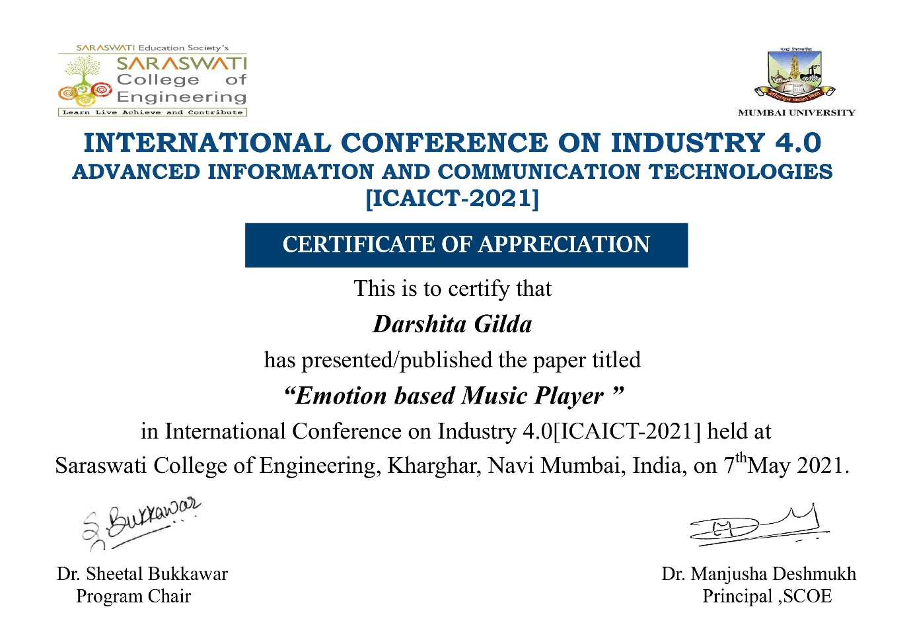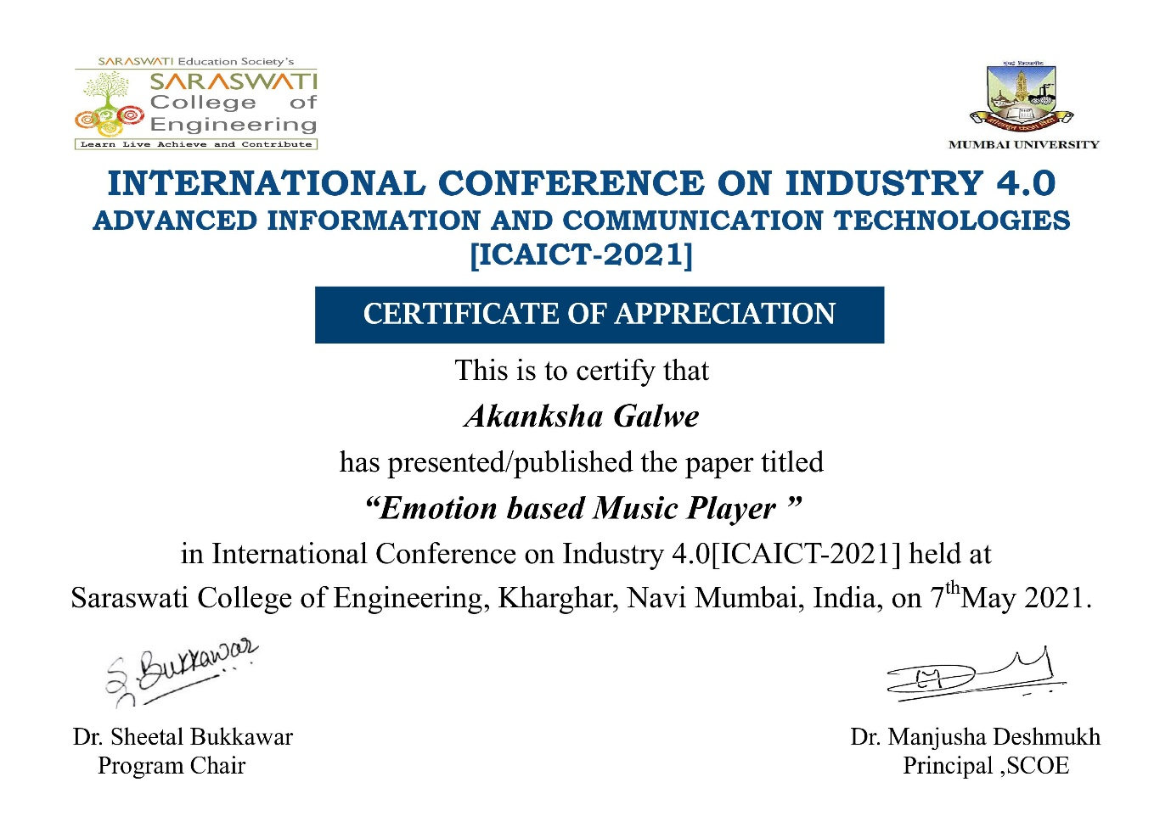

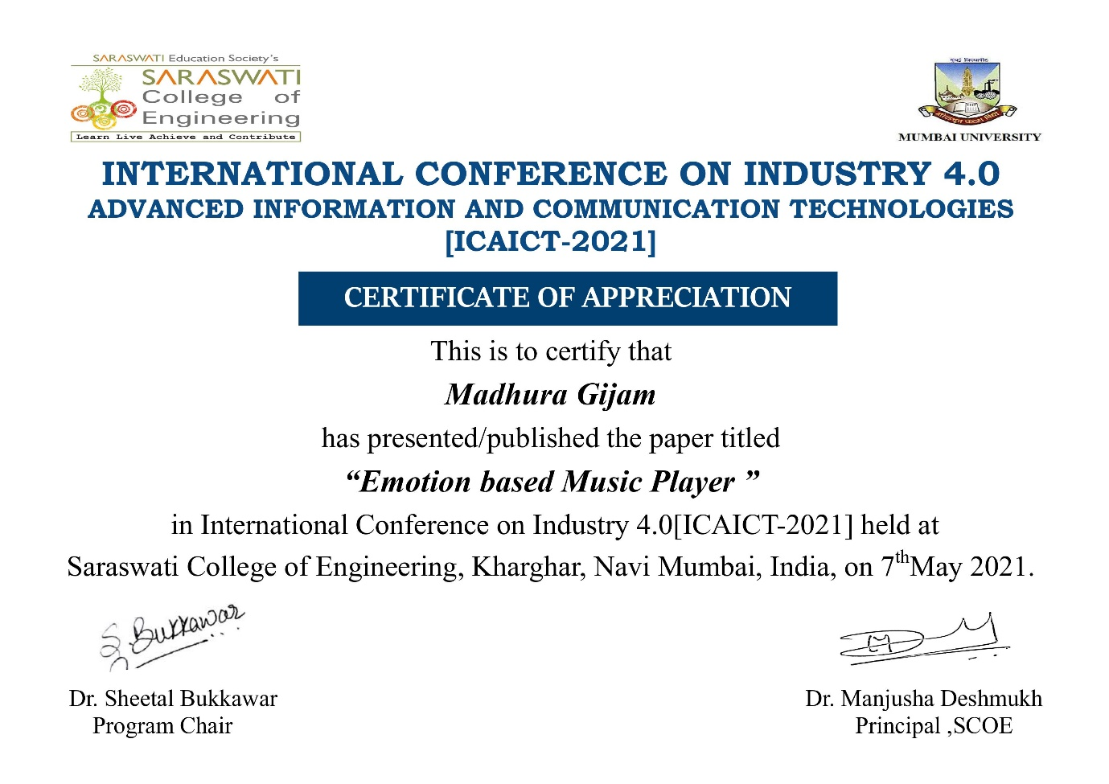

**Acknowledgments**

Date: